SIMATS ENGINEERING (SAVEETHA SCHOOL OF ENGINEERING)
Department of Computer Science and Engineering
CO2 ASSESSMENT TOOL 1 – Scenario-Based Requirement Analysis

Course Code: | CSA10 / CSA1005 | Course Title: | Software Engineering
CO Assessed: | CO2 | Assessment: | Assessment Tool 2 – Scenario-Based Requirement Analysis
Weightage: | 20% | Total Marks: | 25
CO2 Statement: | Perform detailed requirements analysis, design scalable architectures, and prioritize features with a focus on cross-disciplinary skills
Student Name: | Dharshavardhan SB | Reg. No.: | 192420039
Date: | 27.10.26 | Duration: | 60 minutes

Code of Conduct
I Dharshavardhan 192420039 (Name / Reg No) certify that this submission is my original work and that I have adhered to the guidelines specified for this assessment. I understand that any violation of academic integrity rules will result in disciplinary action.
Signature of the Student: dharshavardhan
Annexure A – Scenario-Based Requirement Analysis
Instructions to Students:
Each student will be assigned an individual software project problem statement. Analyze the given scenario and prepare a complete Software Requirement Analysis document by following the steps below.

Question
Based on the assigned problem statement, perform a Scenario-Based Requirement Analysis and prepare a Software Requirement Specification (SRS) document. Your analysis should include the following:

- Study and Analyze the Scenario
  - Carefully understand the given problem statement.
  - Identify the business domain, stakeholders, existing challenges, and system objectives.
- Identify Functional and Non-Functional Requirements
  - List all functional requirements required by the proposed system.
  - Identify suitable non-functional requirements such as performance, security, reliability, usability, scalability, maintainability, and availability.
- Identify Actors and Use Cases
  - Identify all primary and secondary actors interacting with the system.
  - List the major use cases associated with each actor.
  - Draw a Use Case Diagram representing the interactions between actors and the system.
- Prepare the Software Requirement Specification (SRS)
Develop an SRS document containing:
  - Introduction
  - Problem Description
  - Scope of the System
  - Functional Requirements
  - Non-Functional Requirements
  - Use Case Descriptions
  - Data Requirements
  - External Interface Requirements
  - System Features
- Identify Assumptions and Constraints
  - List the assumptions considered while developing the system.
  - Identify technical, operational, economic, legal, and time-related constraints affecting the project.
- Validate Requirement Completeness and Consistency
  - Verify whether all stakeholder requirements have been addressed.
  - Check for ambiguity, redundancy, inconsistency, and missing requirements.
  - Suggest improvements to enhance the quality and completeness of the requirement specification.
Rubrics for Calculation
Criteria | Excellent (4 Marks) | Good (3 Marks) | Satisfactory (2 Marks) | Needs Improvement (1 Mark)
Scenario Understanding and Problem Analysis (30%) | Demonstrates thorough understanding of the scenario, stakeholders, objectives, and business context with clear analysis. | Demonstrates good understanding with minor omissions. | Basic understanding with limited analysis. | Poor understanding; major aspects missing or incorrect.
Functional and Non-Functional Requirement Identification (25%) | Clearly identifies comprehensive, accurate, and well-classified functional and non-functional requirements. | Identifies most requirements with minor classification errors. | Identifies only basic requirements; several omissions. | Requirements are incomplete, inaccurate, or poorly classified.
Actor Identification and Use Case Modelling (20%) | Correctly identifies all relevant actors and use cases; use case diagram is complete, accurate, and follows UML standards. | Most actors and use cases identified; diagram has minor errors. | Limited actors/use cases identified; diagram partially correct. | Actors/use cases missing or incorrect; diagram absent or inaccurate.
Software Requirement Specification (SRS) Documentation (15%) | SRS is well-structured, complete, professionally organized, and includes all required sections. | SRS is organized with minor missing sections or formatting issues. | SRS includes only essential sections with limited detail. | SRS is incomplete, poorly organized, or lacks essential components.
Assumptions, Constraints, and Requirement Validation (10%) | Clearly identifies realistic assumptions and constraints; validates requirements for completeness, consistency, and ambiguity with appropriate justification. | Identifies most assumptions and constraints; validation is adequate. | Limited assumptions/constraints; validation is superficial. | Assumptions, constraints, and validation are missing or incorrect.

Criteria | Mark
Scenario Understanding and Problem Analysis (30%) | /5
Functional and Non-Functional Requirement Identification (25%) | /5
Actor Identification and Use Case Modelling (20%) | /5
Software Requirement Specification (SRS) Documentation (15%) | /5
Assumptions, Constraints, and Requirement Validation (10%) | /5
TOTAL | /25

SMART CONFERENCE PAPER SUBMISSION AND REVIEW SYSTEM
Scenario-Based Requirement Analysis and Software Requirement Specification (SRS)

1. Study and Analyze the Scenario

1.1 Introduction
The Smart Conference Paper Submission and Review System is a web-based platform designed to manage the complete workflow of an academic conference. It supports author registration, paper submission, reviewer allocation, peer review, revision handling, acceptance decisions, camera-ready paper collection, notifications, and conference reporting.

1.2 Business Domain
The system belongs to academic conference management and scholarly publishing. It supports conference organizers, authors, reviewers, program committee members, and system administrators.

1.3 Stakeholders

• Authors: register, submit manuscripts, respond to reviewer comments, and upload final papers.
• Conference Chair / Organizer: configure the conference, manage deadlines, monitor submissions, and publish decisions.
• Program Committee: oversee reviewer assignment and review progress.
• Reviewers: evaluate assigned papers and submit confidential review reports.
• System Administrator: manage accounts, access permissions, backups, and technical settings.
• Conference participants: may access published conference information or accepted-paper listings when enabled.

1.4 Existing Challenges
• Manual handling of many submissions can cause delays and duplicate records.
• Reviewer allocation can be difficult when expertise, workload, or conflicts of interest must be considered.
• Email-based review processes may expose confidential information or lose important messages.
• Revision versions and final camera-ready files can be difficult to track.
• Deadline reminders, decision communication, and conference statistics require additional administrative effort.

1.5 System Objectives
• Manage author registrations and user roles.
• Accept and securely store research paper submissions.
• Allocate papers to suitable reviewers while checking conflicts of interest.
• Collect review reports and track review status.
• Manage revision submissions and final camera-ready files.
• Generate acceptance, rejection, or revision decisions and notify users.
• Track deadlines and provide conference analytics and reports.

2. Functional Requirements
FR-01 User Registration and Login: The system shall allow authors, reviewers, organizers, and administrators to register or receive accounts and authenticate securely.
FR-02 Role Management: The system shall provide role-based permissions so users can access only the functions allowed for their role.
FR-03 Conference Setup: The organizer shall be able to configure conference details, submission rules, tracks, deadlines, review criteria, and notification settings.
FR-04 Paper Submission: Authors shall be able to enter paper metadata and upload manuscript files in permitted formats before the deadline.
FR-05 Submission Validation: The system shall check required fields, file type, file size, and duplicate submission identifiers before accepting a paper.
FR-06 Reviewer Profile: Reviewers shall be able to maintain research interests, expertise keywords, and availability.
FR-07 Reviewer Allocation: The organizer or authorized committee member shall assign reviewers based on expertise, workload, and availability.
FR-08 Conflict-of-Interest Management: The system shall allow conflicts to be declared and shall prevent or flag assignments where a conflict exists.
FR-09 Review Workflow: Reviewers shall access assigned papers and submit scores, comments, recommendations, and review forms before the deadline.
FR-10 Confidentiality: Reviewer identities and confidential comments shall be visible only to authorized roles according to conference policy.
FR-11 Revision Management: Authors shall receive revision requests and upload revised versions with responses to reviewer comments.
FR-12 Decision Management: Authorized organizers shall record decisions such as accept, reject, or revise and release them to authors.
FR-13 Camera-Ready Submission: Accepted authors shall upload final camera-ready papers and any required supplementary files.
FR-14 Notifications: The system shall send notifications for registration, submission confirmation, assignments, deadlines, reviews, decisions, and final-paper reminders.
FR-15 Deadline Tracking: The system shall display deadlines, submission statuses, overdue reviews, and pending tasks.
FR-16 Conference Analytics: The system shall generate reports on submissions, review completion, acceptance rates, reviewer workload, and paper status.
FR-17 Audit Trail: The system shall record important actions such as assignments, review submission, decision changes, and file updates.
FR-18 Data Export: Authorized users shall be able to export conference reports in commonly used formats such as CSV or PDF.

3. Non-Functional Requirements
Performance: Common pages should load within approximately three seconds under normal expected usage; uploads and report generation should provide progress or status feedback.
Security: Use secure authentication, role-based access control, encrypted network communication, and protected storage for manuscripts and reviews.
Confidentiality: Only authorized users may view unpublished manuscripts, reviewer identities, review comments, and decisions before release.
Reliability: The system should handle expected conference traffic without losing accepted submissions or review data.
Availability: The platform should be available throughout submission and review periods, except for planned maintenance.
Usability: Forms, deadlines, statuses, and error messages should be clear and consistent across devices.
Scalability: The architecture should support increased numbers of users, papers, reviewers, and conferences.
Maintainability: The application should use modular components, documented interfaces, and maintainable code.
Compatibility: The web interface should work on current major browsers and common desktop and mobile screen sizes.
Backup and Recovery: The system should perform scheduled backups and support restoration after data loss or service failure.

4. Actors and Use Cases

4.1 Primary and Secondary Actors
• Author – registers, submits papers, checks status, uploads revisions, and submits camera-ready files.
• Reviewer – maintains expertise, views assigned papers, declares conflicts, and submits reviews.
• Conference Organizer / Chair – configures conference settings, manages assignments, releases decisions, and views reports.
• Program Committee Member – supports reviewer allocation and review monitoring when authorized.
• System Administrator – manages user access, system configuration, maintenance, and backups.
• Notification Service – sends email or in-system alerts triggered by workflow events.

4.2 Major Use Cases
• Author: Register/Login; Edit Profile; Submit Paper; Track Submission; View Decision; Upload Revision; Upload Camera-Ready Paper.
• Reviewer: Login; Update Expertise; Declare Conflict; View Assigned Papers; Submit Review; Update Review Before Deadline if permitted.
• Organizer: Create Conference; Configure Deadlines; Manage Tracks; Assign Reviewers; Resolve Conflicts; Monitor Reviews; Record Decisions; Send Notifications; Generate Reports.
• Administrator: Manage Accounts and Roles; Configure Security; Back Up and Restore Data; Review Audit Logs.

4.3 Use Case Diagram (Text Representation)
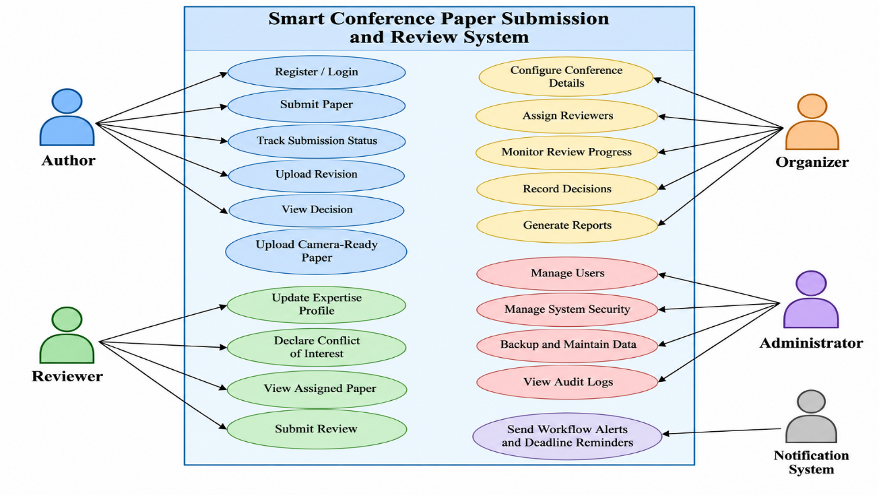

5.1 Purpose
This SRS defines the functional and non-functional requirements for the Smart Conference Paper Submission and Review System. It is intended for developers, testers, conference organizers, and other stakeholders.

5.2 Scope
The system manages the conference paper lifecycle from user registration and initial submission through peer review, revision, decision communication, and final camera-ready collection. It also provides conflict-of-interest controls, deadline tracking, notifications, audit records, and reporting. It does not itself determine the scientific merit of a paper; reviewers and authorized conference staff make those decisions.

5.3 Product Perspective
The product is a centralized web application with a user interface, application logic, database, file storage, and notification service. Users interact through a browser. Email integration may be used to deliver alerts, while the system remains the primary record of submission and review status.

5.4 Operating Environment
• Client: current desktop and mobile web browsers.
• Server: web/application server hosting the system logic and APIs.
• Database: relational database for accounts, papers, assignments, reviews, decisions, and audit records.
• File storage: protected storage for manuscript versions, review attachments, and final papers.
• External service: email gateway or notification provider, if configured.

5.5 Use Case Descriptions

UC-01 Submit Paper
Primary actor: Author. Preconditions: author is authenticated and the submission deadline is open. Main flow: author selects a track, enters title/abstract/keywords, uploads the manuscript, confirms declarations, and submits. The system validates the fields and file, stores the submission, assigns an ID, records a timestamp, and sends confirmation. Alternative flow: invalid file or missing field is reported and the author is asked to correct it.

UC-02 Assign Reviewers
Primary actor: Organizer. Preconditions: paper is submitted and reviewer profiles exist. Main flow: organizer views eligible reviewers, checks expertise and workload, reviews conflict warnings, selects reviewers, and confirms assignment. The system records assignments and notifies reviewers. Alternative flow: a conflict is detected, and the assignment is blocked or flagged for resolution.

UC-03 Submit Review
Primary actor: Reviewer. Preconditions: reviewer is authenticated, assigned to the paper, and the review deadline is open. Main flow: reviewer opens the assigned paper, completes the review form, adds comments and recommendation, and submits. The system validates required fields, timestamps the review, locks it according to policy, and updates review status.

UC-04 Submit Revision
Primary actor: Author. Preconditions: a revision decision has been released and the revision deadline is open. Main flow: author reads comments, uploads a revised manuscript and response document, and submits. The system stores a new version and links it to the original submission.

UC-05 Release Decision
Primary actor: Organizer. Preconditions: sufficient reviews are available and the organizer has decision permission. Main flow: organizer reviews reports, records a decision and author-facing comments, confirms release, and the system notifies the author while recording the decision history.

UC-06 Submit Camera-Ready Paper
Primary actor: Author. Preconditions: paper is accepted and final-submission period is open. Main flow: author uploads the final file and required metadata; the system validates and stores it, then confirms receipt.

UC-07 Generate Conference Report
Primary actor: Organizer. Preconditions: organizer is authenticated and has reporting permission. Main flow: organizer selects a report type and date range; the system aggregates submission, review, decision, or workload data and displays or exports the report.

5.6 Data Requirements
• User data: user ID, name, email, role, affiliation, account status, and authentication data stored securely.
• Conference data: conference ID, title, dates, tracks, policies, submission and review deadlines.
• Paper data: paper ID, title, abstract, keywords, track, authors, submission timestamp, status, and file-version references.
• Reviewer data: reviewer ID, expertise keywords, workload, availability, and declared conflicts.
• Assignment data: paper ID, reviewer ID, assignment date, due date, and assignment status.
• Review data: review ID, scores, comments, recommendation, submission time, and confidentiality/access flags.
• Decision data: decision type, date, authorized decision maker, and message released to the author.
• Notification and audit data: event type, recipient, timestamp, delivery status, and action history.

5.7 External Interface Requirements
• User interface: accessible forms and dashboards for authors, reviewers, organizers, and administrators.
• Email interface: sends event-driven messages and deadline reminders; delivery failures should be logged.
• File interface: accepts only configured file formats and size limits, validates uploads, and prevents unauthorized downloads.
• Reporting interface: provides on-screen summaries and authorized export of conference statistics.
• Database interface: application services validate and store structured records through controlled database access.

5.8 System Features
• Submission management: metadata entry, file upload, validation, unique submission ID, and version tracking.
• Reviewer allocation: expertise matching, workload visibility, assignment status, and conflict checks.
• Peer review: structured scoring, comments, recommendation, and review deadline monitoring.
• Decision and revision workflow: decision recording, author notification, revision uploads, and final-paper collection.
• Conference administration: deadline configuration, track management, user roles, audit trail, and analytics.

6. System Architecture
The proposed architecture separates the presentation layer, application services, data storage, and external notification service. This separation supports maintainability and controlled access to confidential conference data.

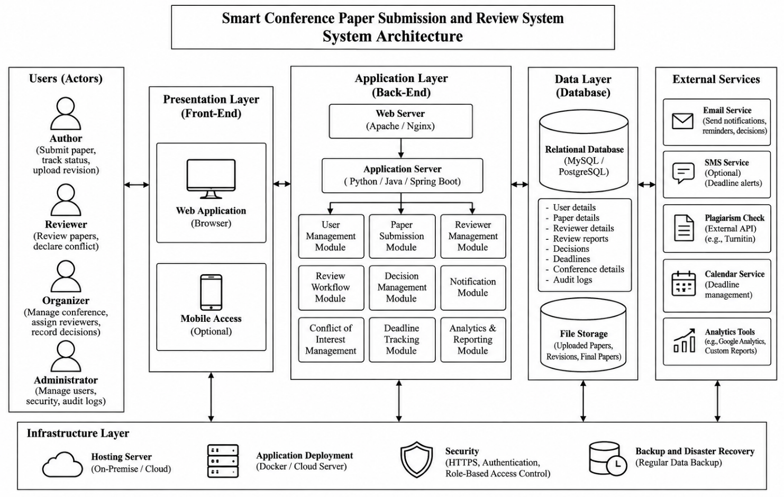

7. Workflow of the System
1. Organizer creates the conference and configures tracks, requirements, review criteria, and deadlines.
2. Authors register, complete their profiles, and submit papers before the deadline.
3. The system validates submissions, stores files, and issues confirmation messages.
4. Organizer or program committee assigns reviewers using expertise and workload information.
5. Conflict-of-interest checks are completed before assignments are confirmed.
6. Reviewers submit confidential review reports within the review period.
7. Organizer considers the reviews and records accept, reject, or revise decisions.
8. Authors receiving revision requests submit revised files and response documents.
9. Accepted authors submit camera-ready papers before the final deadline.
10. The system sends notifications and generates conference analytics and final records.

8. Assumptions and Constraints

8.1 Assumptions
• Users have access to the internet and a supported web browser.
• Authors provide accurate submission metadata and have permission to submit the work.
• Reviewers maintain accurate expertise profiles and declare known conflicts.
• Conference organizers define deadlines, review criteria, and decision policies before the workflow begins.
• An email service is available if email notifications are enabled.

8.2 Constraints
• Technical: the application depends on server, database, file storage, and network availability.
• Operational: assignments and decisions depend on reviewer availability and conference policies.
• Economic: hosting, storage, email delivery, maintenance, and support may incur costs.
• Legal and ethical: personal data and unpublished manuscripts must be handled according to applicable privacy, copyright, and institutional rules.
• Time: submissions, revisions, reviews, and final files must follow configured deadlines.
• Security: reviewers must not access papers outside their assignments; conflicts and confidentiality restrictions must be enforced.

9. Requirement Completeness and Consistency Validation
• Stakeholder coverage: author, reviewer, organizer, program committee, administrator, and notification service needs are represented.
• Lifecycle coverage: requirements cover registration, submission, assignment, review, revision, decision, camera-ready upload, notification, and reporting.
• Security validation: role permissions, confidentiality, conflict checks, and audit records are included.
• Consistency: the paper status should follow a defined workflow, and only authorized users should change decisions or assignments.
• Completeness: each important workflow has preconditions, main steps, and alternative/error handling.
• Testability: requirements use observable actions such as validating uploads, blocking conflict assignments, recording timestamps, and generating reports.
• Recommended improvement: define exact file-size limits, accepted file formats, password policy, retention period, backup frequency, and performance targets during implementation planning.

10. Expected Outcomes
• Streamlined conference management through a centralized digital workflow.
• Reduced administrative effort by automating validation, notifications, and reporting.
• Improved reviewer coordination through assignment tracking and workload visibility.
• Better confidentiality and conflict management through role permissions and checks.
• Reduced submission errors through required-field and file validation.
• Clear tracking of revisions, decisions, deadlines, and final papers.
• Centralized conference records and useful analytics for organizers.

11. Conclusion
The Smart Conference Paper Submission and Review System provides a structured solution for managing the full academic conference paper lifecycle. Its functional requirements define the main services, while non-functional requirements address security, confidentiality, reliability, usability, and scalability. The proposed architecture, use cases, workflow, assumptions, constraints, and validation checks provide a foundation for design, implementation, and testing.

11.REFERENCE
1. Stergiopoulos, V., Vassilakopoulos, M., Tousidou, E., Kavvathas, S., & Corral, A. (2025). Conference Management System Utilizing an LLM-Based Recommendation System for the Reviewer Assignment Problem. Proceedings of the 27th International Conference on Enterprise Information Systems (ICEIS), 1004–1011.
Publication Details
2. Pakpahan, A. F. (2025). Design and Implementation of Full-Stack Conference System for Streamlined Administrative Workflows. CogITo Smart Journal, 11(2), 368–381.
CogITo Smart Journal
3. Soares, J., & Carvalho, P. (2025). Design and Implementation of a Conference Management System for Use in Academic Institutions. Simpósio de Engenharia Informática 2025.
Recipp
4. Wicaksono, P., Nur Aziezah, & Sholihah, W. (2026). Digitalizing Scholarly Communication: Development and Functional Validation of a Web-Based Scientific Conference Management System. Current STEAM and Education Research.
Current STEAM and Education Research
5. Uçar, T., & Duman, B. (2026). A Modular LLM-Driven System for Managing Academic Submissions and Editorial Workflow. Computer Science.

Computer Science
6. Harshwardhan, K., Vani, M. N., Varma, Y., Veneela, N., Karthik, K., & Mande, U. (2026). AI-Enabled Review Management System: An Integrated Platform for AI-Assisted Academic Submission Review. International Journal of Engineering Research and Science & Technology, 22(2).
IJERS
7. Qudoos, A., Khaliq, A., Arain, A. A., Furqan, M., & Ali, S. (2025). Smart Conference Management System (SCMS). International Journal of Innovations in Science & Technology.
50sea Journals
8. Biswas, J., Schoepp, S., Opipari, A., Zhang, A., Joseph, S., Li, J. J., et al. (2026). AI-Assisted Peer Review at Scale: The AAAI-26 AI Review Pilot. arXiv preprint.

9. Khalid, S., Almutairi, S., Namoun, A., Khan, J., & Khattak, H. A. (2025). Comprehensive Review of Academic Search Systems: Evolution, Analysis, and Future Research Directions. Social Network Analysis and Mining, 15, 66.
10. Pendyala, K. K. V. S. (2025). Automated Research Review Support Using Machine Learning, Large Language Models, and Natural Language Processing. Electronics, 14(2), 256.

